

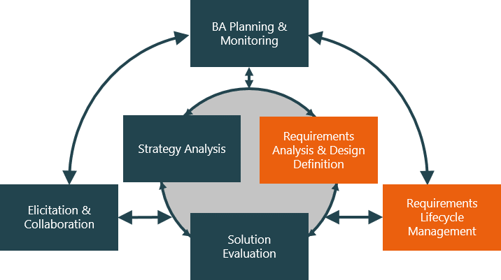

| Name of Student | TSAI-JIE,SUN | ID | 18131 |
| --- | --- | --- | --- |

# Assessment –

# Research & Questioning

Contents

Assessment – 1

Research & Questioning 1

***Instructions:*** 1

***Business Scenario*** 1

***Task 1: Determine support areas*** 2

***Task 2: Identify stakeholders*** 3

***Task 3: Develop support procedures*** 4

***Task 4: Assign Support Personnel*** 6

***Task 5: Short Answer Questions*** 6

***Task 6: Multiple Choice Questions*** 7

Index 12

#### View My Web Support:

<https://arianesun.github.io/ECBR18131/>

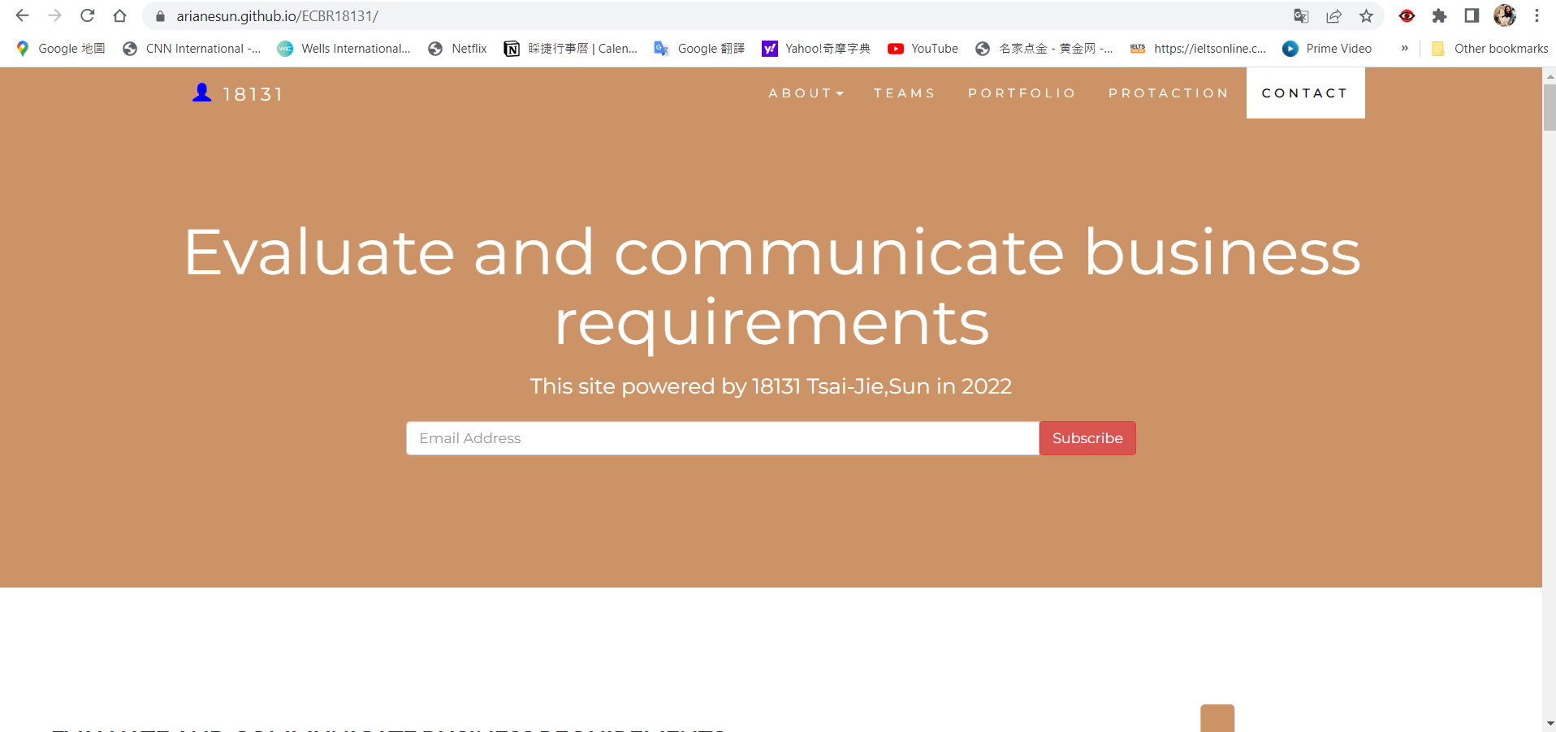

#### ***Instructions:***

This assessment is to be completed individually. In this assessment you will be working through a number of written tasks based on case scenarios or research that relate directly to each element of competency for this cluster. Outlined below is information on how each of the tasks relates the element of competency covered.

Learn how to make Google Form: <https://www.youtube.com/watch?v=BtoOHhA3aPQ&t=4s>

Your tasks:

#### ***Business Scenario***

D&K Books Pty Ltd is a bookstore owned by Mr. Dean Kerr. The business occupies two levels of an office building connected by escalators and lifts. D&K Books employs approximately six sales staff, one operation manager, two administrative officers, a bookkeeper and a marketing manager. They have an Ethernet network consisting of ten PCs (Intel I3 Desktop cloned), two switches, a router and three printers. They use the QuickBooks software to manage their entire business, including sales, inventory, ordering, accounts receivable, accounts payable, payroll and employee management. They also have two EFTPOS terminals one on each floor.

D&K Books has a Linux server that stores all of the data including the QuickBooks database. The server is backed up to tape regularly. They also have a website (hosted on an Australian ISP’s server, dynamic and static pages using asp.net) on which customers can browse the product catalogue and view current specials. They also lease a telephone system from Live Telecoms. The PABX (phone system) consists of a main switchboard and five remote phones with three incoming lines and a message-on-hold queue system.

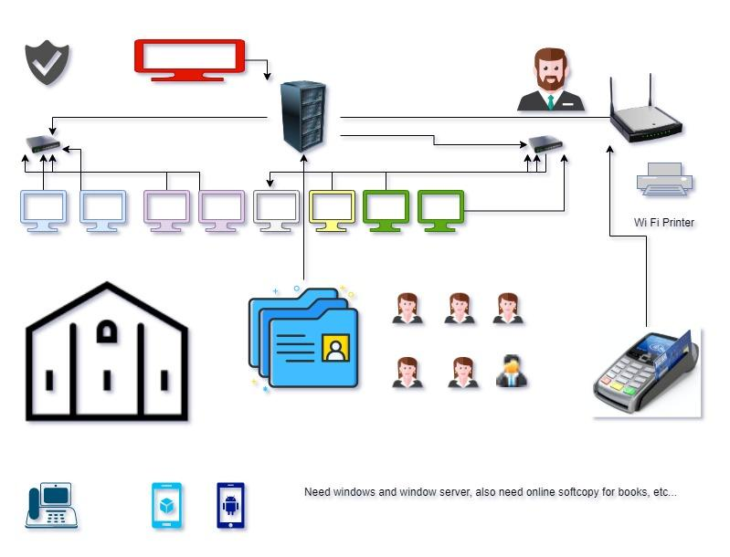

Good network system, you need setup at least:

| Hardware | Software |
| --- | --- |
| Server X 1 | Window Server |
| Router x 1 | Eftpos machine |
| Hardware firewall X 1 | MS office |
| Computer X 8 | Windows |
| Printer X 2 | SQL server |
| Telephone X 8 | Virus Protection |
| Modern X 2 |  |
| Network Cable X 4 |  |

#### ***Task 1: Determine support areas***http://imapwebsolutions.com/wp-content/uploads/2014/07/linux-dedicated-server.png

Identify information technology (HW and SW) and list the technology in use in D&K Books and consider the following:

* What sort of support does the technology require?
* Who is likely to provide this support?
* Does the support arrangement already exist?

Present your answer in a table such as the one below:

| **Technology** | **Description** | **Support Required** | **Provider** | **Support Already exists? (Yes/No)** |
| --- | --- | --- | --- | --- |
| QuickBooks Software | It keeps records of all accounts, databases, stock, GST, etc. | Customization, training, system upgrade, bug fixes (patching), user support and feedback, payroll | [www.intuit.com.au](http://www.intuit.com.au)  online to find more | No |
| PCs | Intel I3 Desktop cloned | Upgrades, repairs, troubleshooting, maintenance, backup, customisation, network to link | Windows | No. We need to hire external staff to do this job. |
| Printer | Connect to the computer to print documents that are needed. | Maintenance, ink, wireless connection. | HP  Canon | Yes, providers will give up support. |
| Server | Linux Server with tape backup  May need upgrade to hard disk backup | User account management, security policy implementation, home folder management, permissions management, backup and restore, operating system patching, software installation | Linux | No, we need to hire external staff to do this job |
| EFTPOS | System for deducting the [cost](https://www.collinsdictionary.com/dictionary/english/cost) of a [purchase](https://www.collinsdictionary.com/dictionary/english/purchase) directly from the customer's bank, building-society, or credit-card account by means of a computer [link](https://www.collinsdictionary.com/dictionary/english/link) using the telephone network. | Maintenance | shop | Yes |
| Telephone system | Low cost | Maintenance | Telstra | Yes |
| Website | Low cost | Update, fix bugs and maintenance | Wix | Yes |
| Network | WIFI wireless connection | Maintenance | No | No |

Please review my website: <https://arianesun.github.io/ECBR18131/>

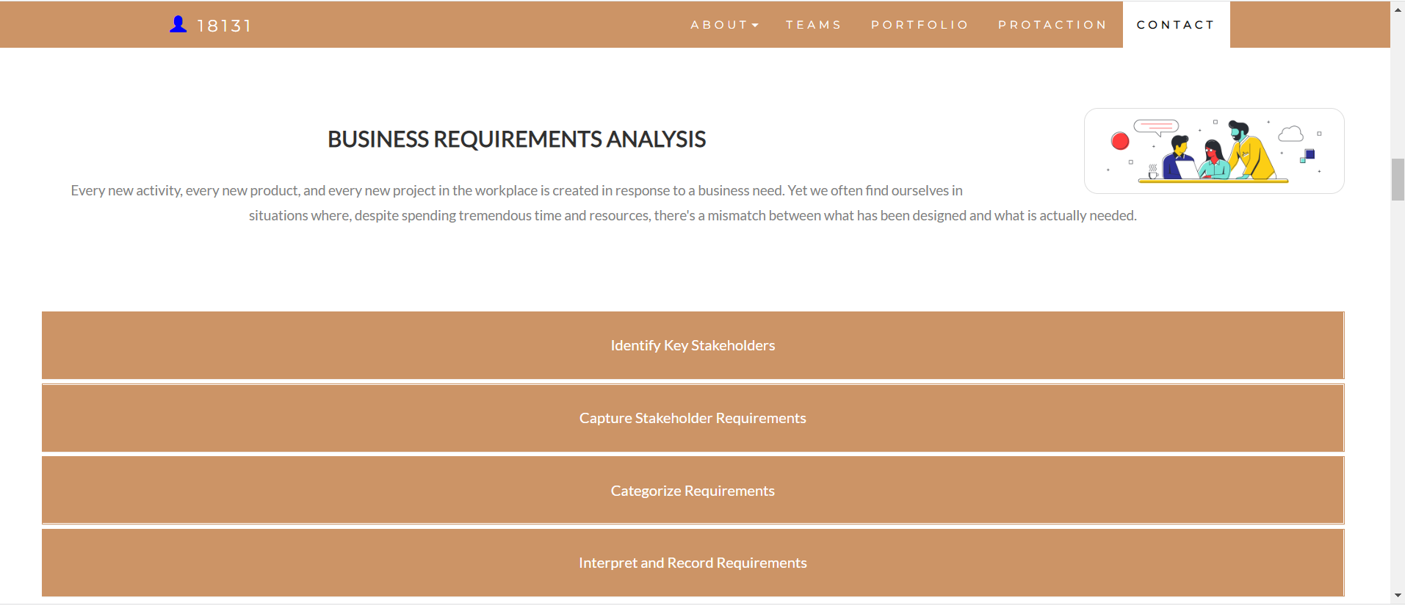

#### ***Task 2: Identify stakeholders***

Identify stakeholders related in D&K Books system

Owner Mr. Dean Kerr., six sales staff, one operation manager, two administrative officers, a bookkeeper, a marketing manager, and all guests.

#### ***Task 3: Develop support procedures***

1. Describe one positive and one negative experience you have had when seeking assistance from a telecommunication company, an ISP or a computer supplier. Your experience may be via telephone, email or even voice recognition.

| Type | Positive | Negative |
| --- | --- | --- |
| Telephone | Most of the time, the staff can solve or answer my questions quickly. I can reach them anytime during their office hours. | It is not easy to understand what they are talking about due to different accents sometimes. Moreover, I often need to wait a long time to get someone to talk to. |
| Email | They can send documents, photos or files easily by email.  It’s also easy to save proof and make everything clear to see. | It may take a long time to wait for a response. |

1. Using the experiences described above please answer the following questions.
   1. What support aspects were professional and/or unprofessional?
   2. How long did the support process take?
   3. Were the steps logical?
   4. Did they solve your problem?
   5. Was the call deflected to another area?

| Items | professional | unprofessional |
| --- | --- | --- |
| What support aspects | Friendly, good interpersonal communication skills and knowledgeable. | Use emotional words, unknowledgeable staff. No manners. |
| How long | Get a response in half a day if you use email. Get the answer straight away after asking the question by phone. | Get a response after 3 days by email, or don't get any suggestions by phone. |
| Steps logical | Yes | No |
| Solve | Yes, they will offer some solutions to resolve our problems. | They can’t not understand what customers need. |
| Another area | Yes, sometimes, other departments may get involved. | No, they don’t care about customers' needs. |

Using feedback form or Google survey form.

Here is the very simple survey demo:

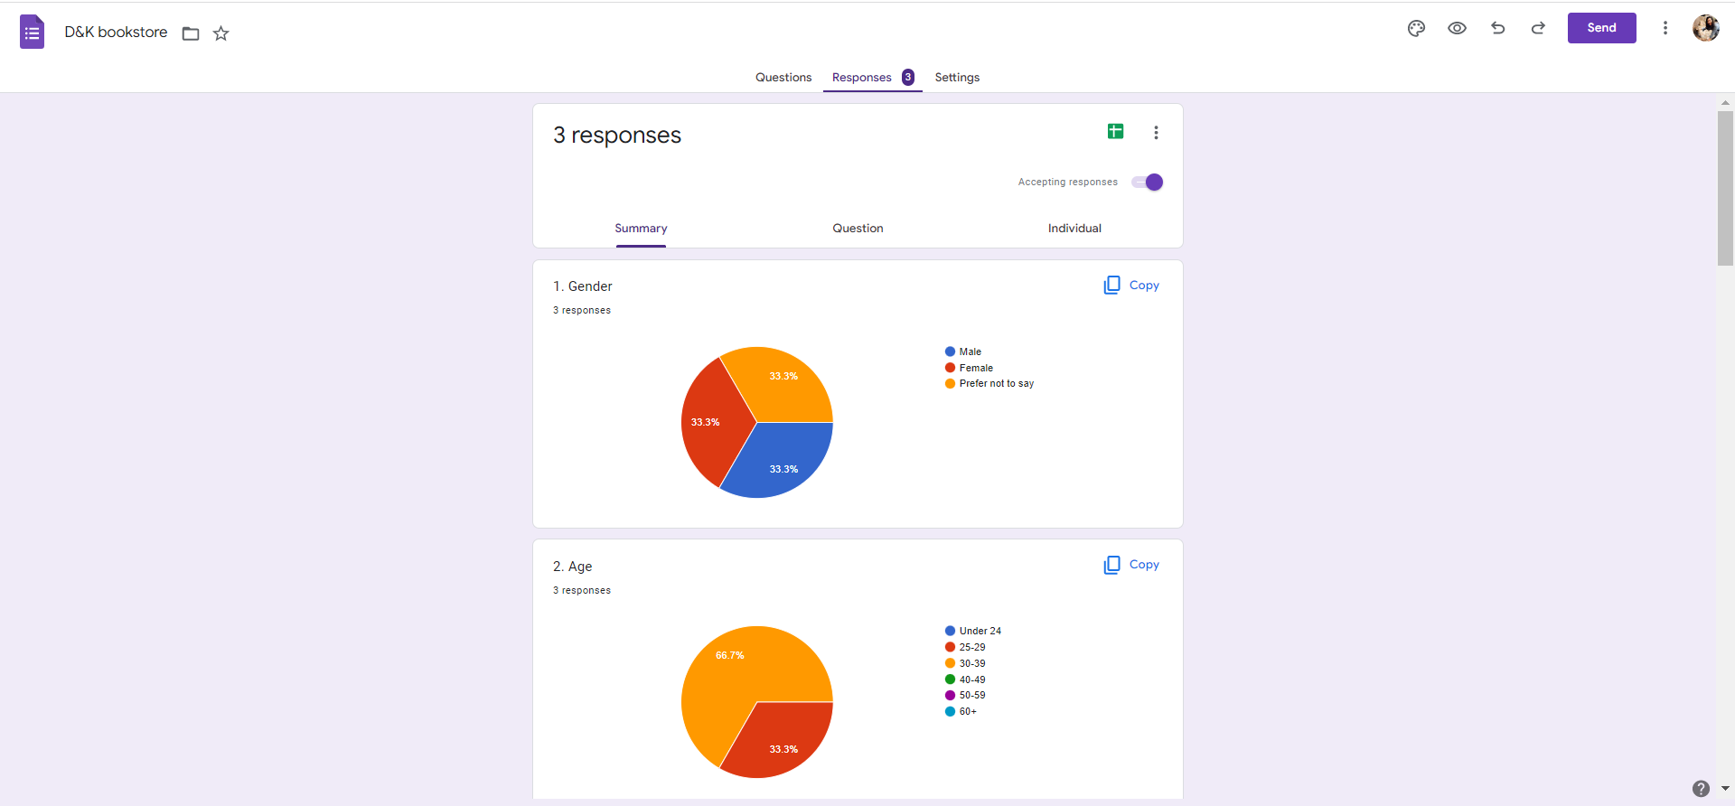

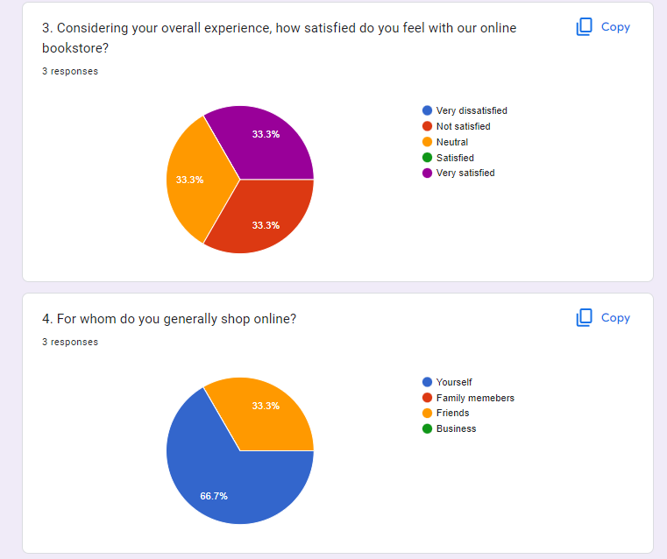

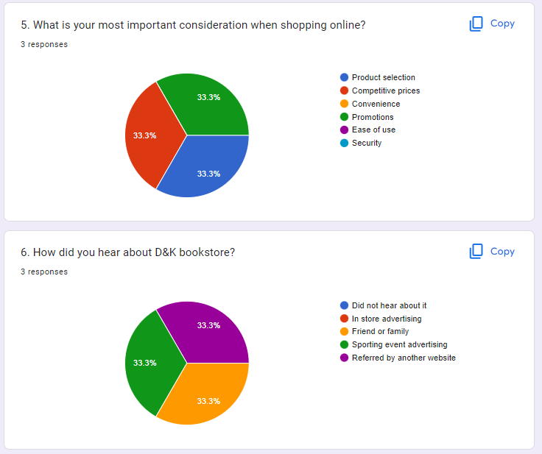

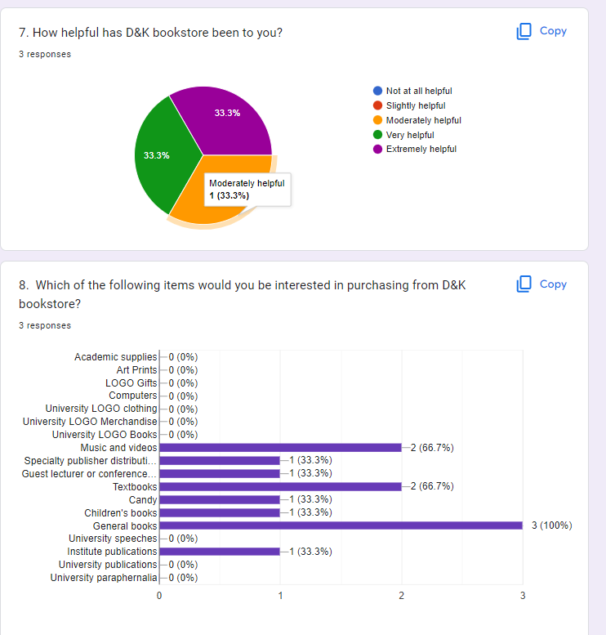

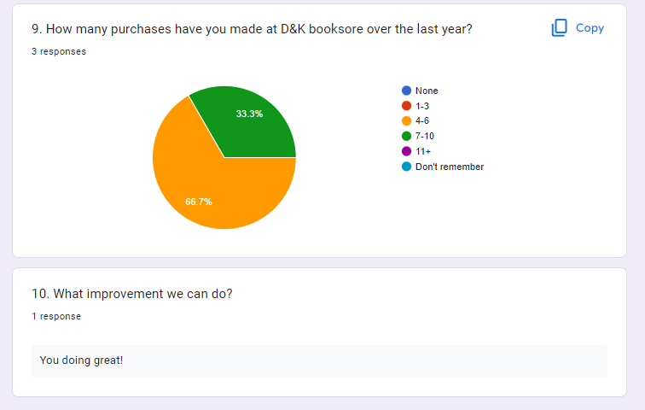

After I tested my friends, I could get nice response like:

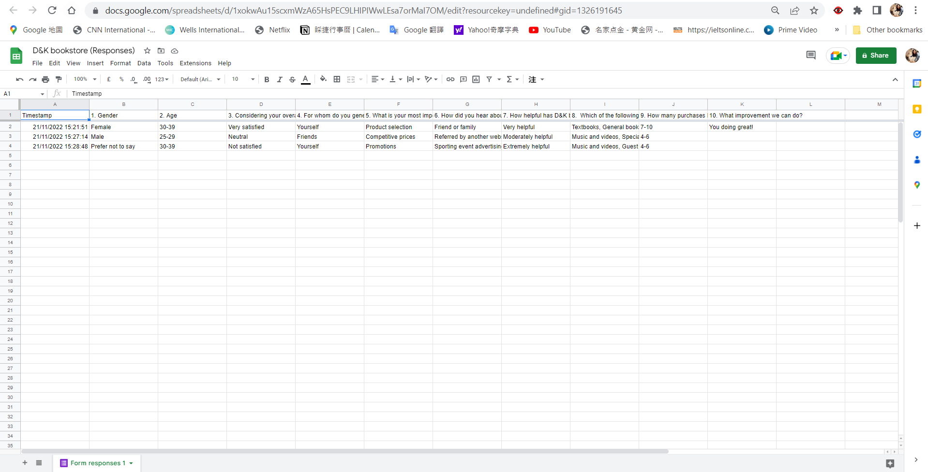

Or using link string:

https://docs.google.com/spreadsheets/d/1xokwAu15scxmWzA65HsPEC9LHIPIWwLEsa7orMaI7OM/edit?resourcekey=undefined#gid=1326191645

Please review my website: <https://arianesun.github.io/ECBR18131/#myPage>

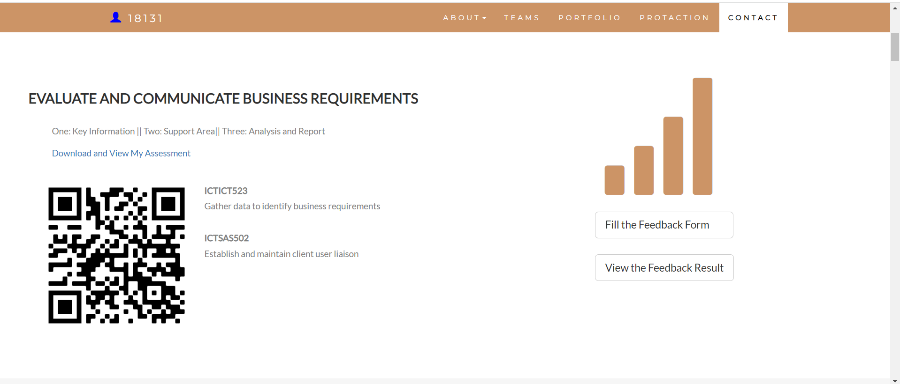

#### ***Task 4: Assign Support Personnel***

Classify the following into soft skills and technical skills. Your answer should take the form of a table shown below.

| **Skill** | **Soft skill** | **Technical skill** |
| --- | --- | --- |
| A knowledge of Linux | X | X |
| The ability to work under pressure | X |  |
| The administration of Windows 2008 Server |  | X |
| The ability to formulate network and IT policies | X | X |
| The ability to write network documentation | X | X |
| The ability to give presentations | X | X |

Here is about document reequipment at support website: <https://arianesun.github.io/ECBR18131/>

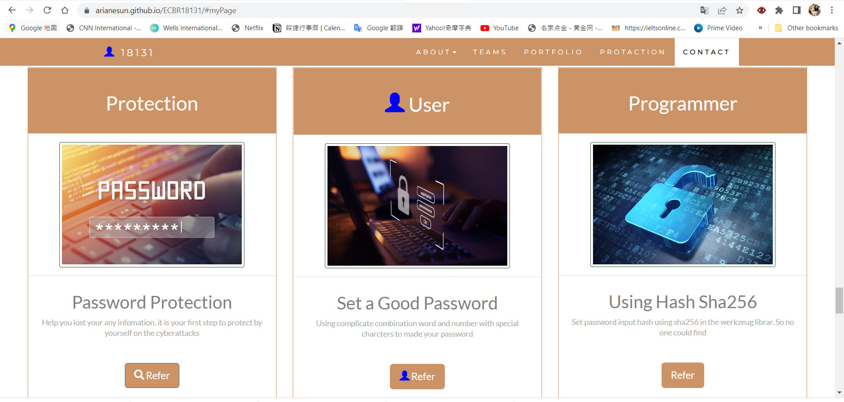

#### ***Task 5: Short Answer Questions***

1. Explain the relationship between data, information and knowledge.

***Data*** are the raw alphanumeric values obtained through different acquisition methods. Data in their simplest form consist of **raw alphanumeric values**. ***Information*** is created when data are processed, organized, or structured to provide context and meaning. Information is essentially **processed data**.

***Knowledge*** is what we know. Knowledge is unique to each individual and is the accumulation of past experience and insight that shapes the lens by which we interpret, and assign meaning to, information. <https://internetofwater.org/valuing-data/what-are-data-information-and-knowledge/#:~:text=Data%20in%20their%20simplest%20form,Knowledge%20is%20what%20we%20know>.

1. What is quantitative data and how can you use it.

Quantitative data is used when a researcher needs to quantify a problem, and answers questions like “what,” “how many,” and “how often.” This type of data is frequently used in math calculations, algorithms, or statistical analysis.

<https://www.fullstory.com/quantitative-data/#:~:text=Quantitative%20data%20is%20used%20when,%2C%20algorithms%2C%20or%20statistical%20analysis>.

1. What is qualitative data and how can you use it.

Qualitative data is descriptive, expressed in terms of feelings rather than numerical values.

Qualitative data analysis cannot be counted or measured because it describes the data. It refers to the words or labels used to describe certain characteristics or traits.

This type of data answers the "why" or "how" behind the analysis. It’s often used to conduct open-ended studies, allowing those partaking to show their true feelings and actions without direction.

1. Give an example of how quantitative and qualitative data can be used in conjunction with each other

The success of marketing events is often judged by hard data such as the number of attendees or sales made during the event. But qualitative research is great for putting a face to a number. By encouraging attendees to fill out a survey, you collect valuable information about attendees, such as demographic info, product feedback and detailed impressions of the event.

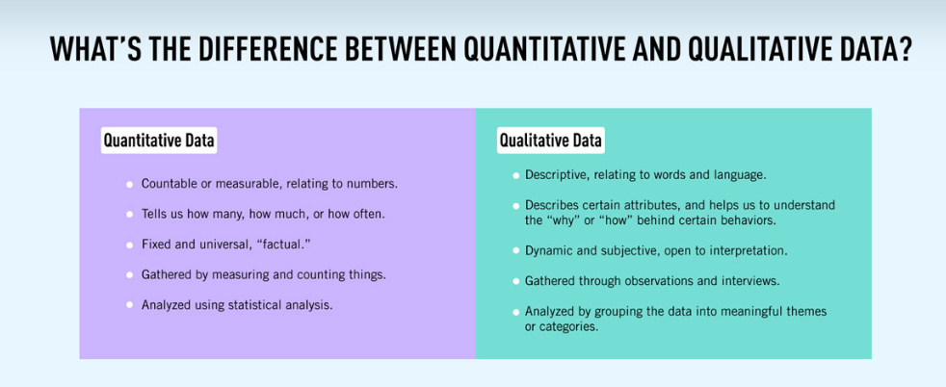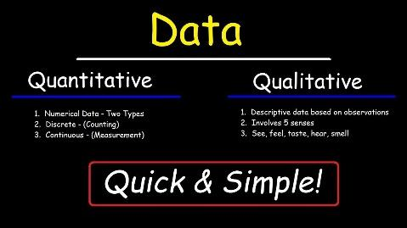

1. What sort of methods could you use to determine client requirements for a website design and key information sources? 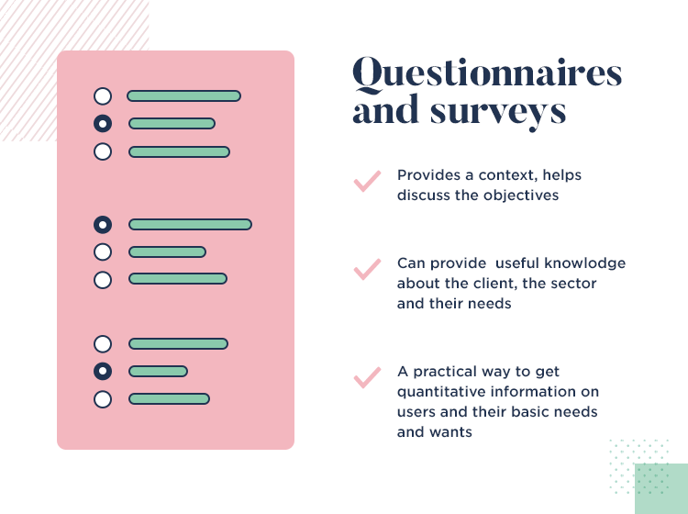

Surveys

Marketing analysis

Online tracking

Subscription and registration data

<https://tasil.com/insights/data-collection-methods/>

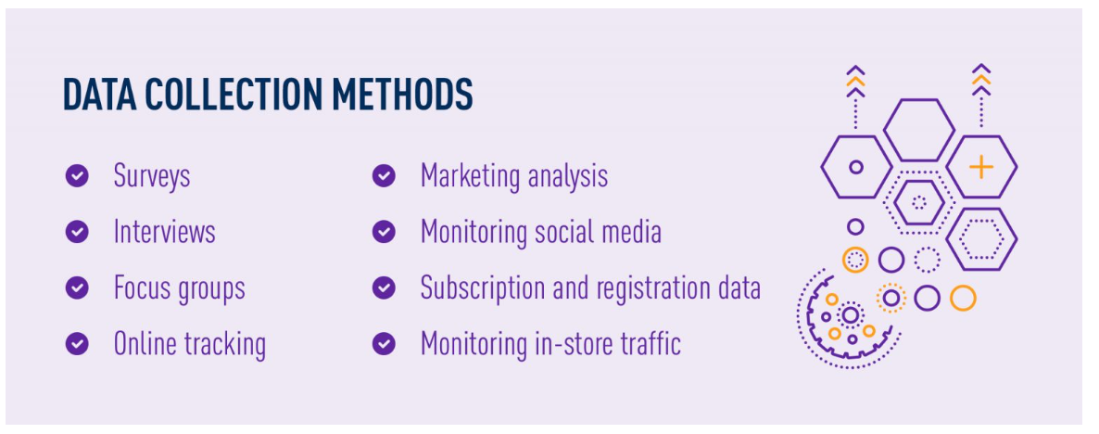

1. Give some examples of client requirements for a website design

Easy to find information they need

Filter option

Looks clear and good

Convenient

I made my web support page, could be accessed by: <https://wellsjohn220.github.io/ecbr>

#### ***Task 6: Multiple Choice Questions***

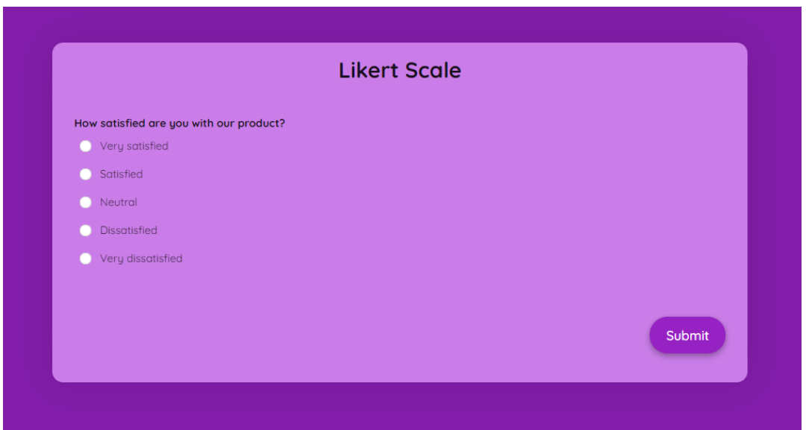

1. Generally, how many points should a rating scale have?

Five

Four

Ten

Somewhere from 4 to 11 points

A likert scale is typically in the form of a [5-point or 7-point rating system](https://www.formpl.us/blog/point-likert-scale) that allows you to objectively rate the survey respondent’s opinions, perceptions, and behaviors. It also includes a moderate or neutral rating that caters to opinions that are neither here nor there.

Web refers: <https://www.formpl.us/blog/rating-scale>

1. What is the problem(s) with this set of response categories to the question “What is your current age?”

* 1-5
* 5-10
* 10-20
* 30-40

The categories are not mutually exclusive

The categories are not exhaustive

Both a and b are problems Reason

There is no problem with the above set of response categories

This question doesn’t clarify each category clearly, there are some certain numbers of age that overlap. When people answer this question they will get confused about which option they should choose, and also the result will not be accurate.

1. You should mix methods in a way that provides complementary strengths and no overlapping weaknesses. This is known as the fundamental principle of mixed research.

True Reason

False

According to the fundamental principle of mixed research, the researcher should use a mixture or combination of methods that has complementary strengths and nonoverlapping weaknesses.

* This principle is important because it provides the researcher with a logic for mixing quantitative and qualitative research approaches.
* Mixing quantitative and qualitative approaches in a haphazard way will produce undesirable results.
* Mixing should be systematic and well thought out by the researcher when planning and designing a research study.

1. According to the text, questionnaires can address events and characteristics taking place when?

In the past (retrospective questions)

In the present (current time questions)

In the future (prospective questions)

All of the above Reason

The person who designs surveys can decide what area they want to research, it can be the past, present or future.

1. Which of the following are principles of questionnaire construction?

Consider using multiple methods when measuring abstract constructs

Use multiple items to measure abstract constructs

Avoid double-barrelled questions

All of the above

Only b and c Reason

1. Which of these is not a method of data collection?

Questionnaires

Interviews

Experiments Reason

Observations

<https://online.hbs.edu/blog/post/data-collection-methods>

1. Secondary/existing data may include which of the following?

Official documents

Personal documents

Archived research data

All of the above Reason

<https://researchguides.ben.edu/c.php?g=282050&p=4036581#:~:text=Secondary%20data%20means%20data%20collected%20by%20someone%20else%20earlier.&text=Surveys%2C%20observations%2C%20experiments%2C%20questionnaire,journal%20articles%2C%20internal%20records%20etc>.

1. An item that directs participants to different follow-up questions depending on their response is called a ____________.

Response set

Probe

Semantic differential

Contingency question Reason

Contingency questions are questions that are only to be answered by some subgroup(s) of respondents. For example, "If you own your home, how long have you owned it?" Contingency questions may have either closed-ended or open-ended response options.

<https://home.csulb.edu/~msaintg/ppa696/696qstin.htm#:~:text=Contingency%20questions%20are%20questions%20that,or%20open%2Dended%20response%20options>.

1. Which of the following terms best describes data that were originally collected at an earlier time by a different person for a different purpose?

Primary data

Secondary data Reason

Experimental data

Field notes

Secondary data is the second-hand information since the secondary data is not collected or gathered by the user. It should be accurate, reliable and suitable. For example, the government census report is a secondary data. Thus, secondary data that we originally collected at an earlier time by a different person for a different purpose.

1. Researchers use both open-ended and closed-ended questions to collect data. Which of the following statements is true?

Open-ended questions directly provide quantitative data based on the researcher’s predetermined response categories

Closed-ended questions provide quantitative data in the participant’s own words

Open-ended questions provide qualitative data in the participant’s own words Reason

Closed-ended questions directly provide qualitative data in the participants’ own words

Open-ended questions are those that provide respondents with a question prompt and provide them a space in which to construct their own response. Closed-ended questions, alternatively, provide a question prompt and ask respondents to choose from a list of possible responses. Factors relating to both the researcher and respondent are important to selecting which question format to utilize.

1. Open-ended questions provide primarily ______ data.

Confirmatory data

Qualitative data Reason

Predictive data

None of the above

Open-ended questions provide primarily qualitative data, and are generally used in exploratory research.

1. Which of the following is true concerning observation?

It takes less time than self-report approaches

It costs less money than self-report approaches

It is often not possible to determine exactly why the people behave as they do

All of the above

1. Qualitative observation is usually done for exploratory purposes; it is also called ___________ observation.

Structured

Naturalistic Reason

Complete

Probed

Naturalistic observation is a [qualitative research](https://www.scribbr.com/methodology/qualitative-research/) method where you record the behaviors of your research subjects in real world settings. You avoid interfering with or influencing any [variables](https://www.scribbr.com/methodology/types-of-variables/) in a naturalistic observation.

You can think of naturalistic observation as “people watching” with a purpose.

1. When constructing a questionnaire, it is important to do each of the following except ______.

Use "leading" or "loaded" questions Reason

Use natural language

Understand your research participants

Pilot your test questionnaire

The main functions of questionnaires are to extract information from respondents, record and process it. To achieve this effectively, a questionnaire should:

* provide clear instructions (for respondents, interviewers and processors);
* clearly and concisely define what is to be collected and recorded;
* maintain respondents' cooperation and involvement;
* enable respondents to complete it accurately and within a reasonable time;
* use a language that is understood by the respondents;
* avoid bias in question wording;
* make the job of the respondent and/or interviewer easy;
* appear uncluttered on the form;
* provide suitable space for responses; and
* be easily processed by both people and machines.
* be in a suitable form for keeping as a hard copy record.

1. Another name for a Likert Scale is a(n):

Interview protocol

Event sampling

Summated rating scale Reason

Ranking

After the questionnaire is completed, each item may be analyzed separately or in some cases item responses may be summed to create a score for a group of items. Hence, Likert scales are often called summative scales.

<https://en.wikipedia.org/wiki/Likert_scale#:~:text=Hence%2C%20Likert%20scales%20are%20often%20called%20summative%20scales>.

1. Which of the following is not one of the six major methods of data collection that are used by educational researchers?

Observation

Interviews

Questionnaires

Checklists

Six Major methods.

Interviews

Questionnaires and surveys

Observations

Documents and records

Focus groups

Oral histories

Reason

1. The type of interview in which the specific topics are decided in advance but the sequence and wording can be modified during the interview is called:

The interview guide approach Reason

The informal conversational interview

A closed quantitative interview

The standardized open-ended interview

* Interviews are completed by the interviewer based on what the respondent says.
* Interviews are a far more personal form of research than questionnaires.
* In the personal interview, the interviewer works directly with the respondent.
* Unlike with mail surveys, the interviewer has the opportunity to probe or ask follow up questions.
* Interviews are generally easier for respondents, especially if what is sought is opinions or impressions. Interviews are time consuming and they are resource intensive.
* The interviewer is considered a part of the measurement instrument and the interviewer has to be well trained in how t o respond to any contingency.

<https://www.public.asu.edu/~kroel/www500/Interview%20Fri.pdf>

1. Which one of the following in not a major method of data collection:

Questionnaires

Interviews Reason

Secondary data

Focus groups

All of the above are methods of data collection



1. A question during an interview such as “Why do you feel that way?” is known as a:

Probe Reason

Filter question

Response

Pilot

1. A census taker often collects data through which of the following?

Standardized tests

Interviews

Secondary data

Observations

As responses to the census roll in, the census generates a list of people who have not yet responded. Census takers go out on foot again to track down those households and collect responses. The census taker is obliged to take every possible step to collect data about nonrespondent households. This includes interviewing neighbors, returning to the housing unit multiple times, attempting to contact landlords, and similar steps.

<https://www.practicaladultinsights.com/what-is-a-census-taker.htm>

Reason

1. The researcher has secretly placed him or herself (as a member) in the group that is being studied. This researcher may be which of the following?

A complete participant Reason

An observer-as-participant

A participant-as-observer

None of the above

This is a fully embedded researcher, almost like a spy. Here the observer fully engages with the participants and partakes in their activities.

Participants aren’t aware that observation and research is being conducted, even though they fully interact with the researcher. This has sometimes been referred to as “going native,” in reference to performing indigenous fieldwork.

In customer research, this is like a secret shopper or the show [Undercover Boss](https://en.wikipedia.org/wiki/Undercover_Boss). The idea is that the best way to understand a type of role, people, or culture is to experience it firsthand.

1. Which of the following is not a major method of data collection?

Questionnaires

Focus groups

Correlational method Reason

Secondary data



1. Which type of interview allows the questions to emerge from the immediate context or course of things?

Interview guide approach

Informal conversational interview Reason

Closed quantitative interview

Standardized open-ended interview

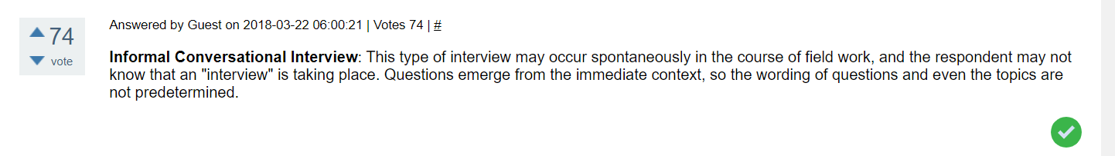

1. When conducting an interview, asking "Anything else?, What do you mean?, Why do you feel that way?," etc, are all forms of:

Contingency questions

Probes Reason

Protocols

Response categories

Probing is asking follow-up questions when we do not fully understand a response, when answers are vague or ambiguous or when we want to obtain more specific or in-depth information. For example: “What did you like best about the program?”

1. When constructing a questionnaire, there are 15 principles to which you should adhere. Which of the following is not one of those principles?

Do not use "leading" or "loaded" questions

Avoid double-barrelled questions

Avoid double negatives

Avoid using multiple items to measure a single construct Reason

Principle 1 Make sure your questionnaire items match your research objectives.

Principle 2 Understand your research participants

Principle 3 Use natural and familiar language.

Principle 4 Write items that are clear, precise, and relatively short.

Principle 5 Do not use “leading” or “loaded” questions.

Principle 6 Avoid double-barreled questions.

Principle 7 Avoid double negatives.

Principle 8 Determine whether an open-ended or a closed-ended question is needed.

Principle 9 Use mutually exclusive and exhaustive response categories available for close-ended questions. Principle 10 Consider the different types of response categories available for close ended questions

Principle 11 Use multiple items to measure abstract constructs.

Principle 12 Consider using multiple methods when measuring abstract constructs.

Principle 13 Use caution if you reverse the wording in some of the items to prevent response set in multi-item scales.

Principle 14 Develop a questionnaire that is easy for the participant to use.

Principle 15 Always pilot test your questionnaire.

1. A customer-based Service Level Agreement structure includes:

An SLA covering all Customer groups and all the services they use

SLAs for each service that are Customer-focused and written in business language

An SLA for each service type, covering all those Customer groups that use that Service

An SLA with each individual Customer group, covering all of the services they use

Customer-based SLA:  
A customer-based SLA is between a service provider and a customer or customer group. It details the services provided, the level of service, and the terms of the relationship. For example, in the relationship between an on-demand video service and a subscriber, a single contract covers the services available, duration of the services provided, and promised uptime. The contract will change for each customer based on the plan they choose. Here the SLA is based on the individual customer.

<https://www.manageengine.com/products/service-desk/automation/what-is-service-level-agreement-sla.html#:~:text=A%20customer%2Dbased%20SLA%20is,the%20terms%20of%20the%20relationship>.

1. Which of the following best describes the goal of Service Level Management?

To maintain and improve IT service quality in line with business requirements Reason

To provide IT services at the lowest possible cost by agreeing with Customers their minimum requirements for service availability and ensuring performance does not exceed these targets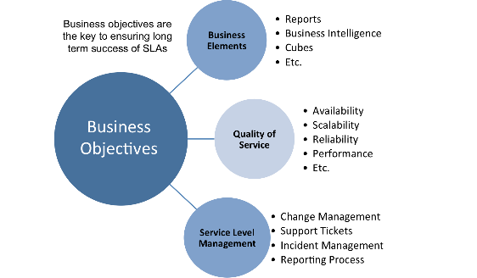

To provide the highest possible level of service to Customers and continuously improve on this through ensuring all services operate at maximum availability

To ensure that IT delivers the same standard of service at the least cost

The goal for SLM is to maintain and improve IT Service quality, through a constant cycle of agreeing, monitoring and reporting upon IT Service achievements and instigation of actions to eradicate poor service – in line with business or cost justification. Through these methods, a better relationship between IT and its Customers can be developed.

1. The process to implement SLAs comprises of the following activities in sequence:

Draft SLAs, catalogue services, review underpinning contracts and OLAs, draft SLRs, negotiate, agree SLAs

Draft SLAs, review underpinning contracts and OLAs, negotiate, catalogue services,

Review underpinning contracts and OLAs, draft SLAs, catalogue services, negotiate, agree SLAs

Catalogue services, establish SLRs, review underpinning contracts and OLAs, negotiate service levels, agree SLAs

ITIL Service Level Management (SLM), encompassing Service Level Agreements (SLAs), Operating Level Agreements (OLAs), Service Catalogues, Underpinning Contracts (UPCs) is more important than these documents suggest. It is a key IT Service Management discipline, and may well be the first point of reference when considering [ITIL implementation](https://www.itilnews.com/ITIL__Back_to_basics_People_Process_and_Technology.html) within an organisation.

SLM relies on the service provider(s) being able to commit to SLAs. This, in turn, implies that some basic service support disciplines (especially Incident and Change Management) are in place and robust enough to allow this. If this is not the case SLM will need to manage Customer expectation carefully until the service provider(s) can commit to formal SLAs.

<https://www.itilnews.com/index.php?pagename=service_level_management>

Reason

1. Which of the following is an example of a service level agreement (SLA) between information systems support unit and a research unit in the laboratories of a large company?

The maximum response time to get the system operational should it fail.

The minimum ‘up-time’.

The types of information that will be provided as standard.

All of the above. Reason

1. Some organisations bring a degree of formality to the internal customer concept by encouraging (or requiring) different parts of the operation to agree on:

Internal service agreements

Service level agreements Reason

Formal provision agreements

Delivery agreements

## Index

**B**

bookstore 1

**C**

categories 6

closed-ended 7

**D**

data collection 9

**L**

Linux server 2

**N**

network 1

**O**

open-ended 7

**S**

Service Level 9

service level agreement 10

service quality 10

soft skills 5

support 3

**T**

technology 2

telecommunications 3